eHRAF Coding

## Info on what we are doing

We want to investigate the eHRAF database’s contents related to the process of “misfortune” (floods, fires, stubbing your toe, etc.) and how misfortunate is caused and explained. We might ask questions like “When people are sick, do they think the spirits are involved?” and “How do they get spirits to not make them sick anymore?”. However, the database is wide and the “Scraping” or data extraction from the website is messy even when done correctly. It is not always clear if the passages coded to relate to misfortune (by their OCM number) also detail how or why the misfortune occurred. Here we want you to detail the misfortune EVENT (what happened), the CAUSE (why did it happen), and the ACTION (what was done in reaction to the misfortune).

The information is in the many passages, but these need to be **coded** by humans before we can run various statistics on the culture. For instance, in some places people may mention spirits as the cause of misfortune should be treated as different from a mention of gods, but in other places they will mention bad luck or *karma*. These must be reduced to variables so that we can compile the data and observe trends

## Start-Up

1. Graphical user interface, application

   Description automatically generatedSelect the MEM-DEV-RA folder on the desktop and navigate through to the coding folder. It should have your initials within it as well as a file “CodingFrame.xlsx” which gives help and examples of the coding you are about to do. The names and locations of the files in this image may differ from what you may see but relatively all the info should be located here.
2. You will want to have open the “CodingFrame.xlsx” as this will give you information about how to code the passage. Be sure to look at the **HELP** tab on the excel sheet.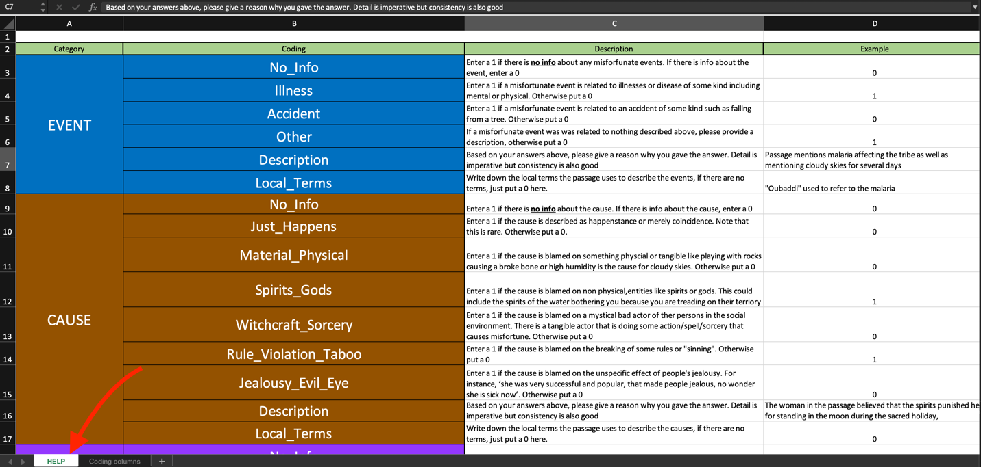
3. Graphical user interface

   Description automatically generated with medium confidenceNext, select your folder and click on a cultural file you will be tasked to code. Any cultural files in your folder are likely to be the ones that are assigned. Double click and open it up.
4. You will see a lot of columns with 5 superordinate columns “CULTURE, EVENT, CAUSE, ACTION, and OTHER”. You will be reading each passage (the “Passage” column) and determining what type of misfortune occurred (the EVENT), how did it happen (the CAUSE), and what did people do in reaction or preparedness to it (the ACTION).
5. Some passages detail multiple events or even events which technically might include multiple types that we are looking for (like if something is both an illness and an accident). Some passages might not even have all the information and just detail a misfortune without any CAUSE or ACTION. Because of the breadth of how eHRAF codes these passages, they are not always consistent and might not even be informative for us. It is okay, just do your best to try to code them accurately and give explanations for your reasoning
6. For each passage, you will code for **everything** for the “EVENT”, “CAUSE”, and “ACTION” even if that means putting “0” for almost every cell (but you always should describe your reasoning). Please see below for an explanation or check out “CodingFrame.xlsx” for quick guide!

## Coding Guide

1. For EVENTs, we want to look at if and when Misfortune appears and what it is. An event could be losing a child, getting rained on at night, or losing one’s keys.
   1. **No_Info**: Enter a 1 if there is no info about any misfortunate events. If there is info about the event, enter a 0
   2. **Illness**: Enter a 1 if a misfortunate event is related to illnesses or disease of some kind including mental or physical. Otherwise put a 0
   3. **Accident**: Enter a 1 if a misfortunate event is related to an accident or physical malady that is not illness related such as falling from a tree or getting a stab wound. Otherwise put a 0
   4. **Other**: If a misfortunate event was related to nothing described above, please provide a description, otherwise put a 0. Additionally, describe what this other event is in the “description” column.
   5. **Description**: Based on your answers above, please give a reason why you gave the answer. Detail is imperative but consistency is also good
   6. **Local_Terms**: Write down the local terms the passage uses to describe the events, if there are no terms, just put a 0 here.
2. For CAUSE, we want to look at what is the reason for a misfortunate even. Did the gods get angry? Did someone break a holy rule? Were they unlucky?
   1. **No_Info**: Enter a 1 if there is no info about the cause. If there is info about the cause, enter a 0
   2. **Just_Happens**: Enter a 1 if the cause is described as happenstance or merely coincidence. Note that this is rare. Otherwise put a 0.
   3. **Material_Physical**: Enter a 1 if the cause is blamed on something physical or tangible like playing with rocks causing a broken bone or high humidity is the cause for cloudy skies. Otherwise put a 0
   4. **Spirits_Gods**: Enter a 1 if the cause is blamed on non-physical, entities like spirits or gods. This could include the spirits of the water bothering you because you are treading on their territory.
   5. **Witchcraft_Sorcery**: Enter a 1 if the cause is blamed on a mystical bad actor of their persons in the social environment. There is a tangible actor that is doing some action/spell/sorcery that causes misfortune. Otherwise put a 0
   6. **Rule_Violation_Taboo**: Enter a 1 if the cause is blamed on the breaking of some rules or "sinning". Otherwise put a 0
   7. **Other:** If there is cause which might not relate to the categories previously described, put a 1. Otherwise put a 0. Additionally, describe what this other cause is in the “description” column.
   8. **Description**: Based on your answers above, please give a reason why you gave the answer. Detail is imperative but consistency is also good
   9. **Local_Terms**: Write down the local terms the passage uses to describe the causes, if there are no terms, just put a 0 here.
3. For ACTION, we want to look at what did people do in reaction or preparedness for misfortune. Perhaps they asked a crystal ball to tell them why their stomach hurts. Maybe they got a priest to bless their sick baby. Maybe they did both of these two so you mark both down in the following list:
   1. **No_Info**: Enter a 1 if there is no info about the action. If there is info about the action, enter a 0
   2. **Material**: Enter a 1 if a resulting action is tangible or physical. Like washing a wound or creating a totem to ward off the bad spirits. Otherwise put a 0
   3. **Technical_Specialist**: Enter a 1 if the resulting action is managed by a someone who has technical knowledge about the situation but does not have some special "mystical" quality. For example, a person who knows the specific roots to help many conditions. Otherwise put 0
   4. **Divination**: Enter a 1 if the resulting action relates to a procedure (usually by a specialist), that reveals what a state or affair or potential issue is. This is often called divination in the literature. Otherwisee, put 0.
   5. **Shaman_Medium_Healer**: Enter a 1 if the resulting action is performed by a "special" person specifically capable with dealing with such cases, e.g., by interacting with the spirits. Otherwise put a 0
   6. **Priest_High_Religion**: Enter a 1 if the resulting action is performed by a person with specific function ordained by a centralized religious authority (a priest, imam, rabbi, Buddhist monk, etc.) OR has a political office (like a chief, king) which gives them special responsibility for the case of misfortune. Otherwise put a 0
   7. **Other**: If there is an action done which might not relate to the categories previously described, put a 1. Otherwise put a 0. Additionally, describe what this other action is in the “description” column.
   8. **Description**: Based on your answers above, please give a reason why you gave the answer. Detail is imperative but consistency is also good
   9. **Local_Terms**: Write down the local terms the passage uses to describe the actions, if there are no terms, just put a 0 here.
4. For OTHER, this is completely optional but you may add comments about the passage if you want to clarify something or give reasoning that might not fit any of the columns like “this passage is a duplicate of 3498”
5. When you find text which relates to one or more of EVENT, CAUSE, or ACTION, it would help to highlight the text in red. This is merely a way to help us get a sense of what text you were considering when you were coding.

## Coding Tips

1. Not every passage will have an EVENT when it has a CAUSE or ACTION. Some only have an ACTION but no EVENT or CAUSE. Others have all three and some more have none of the three. Make sure to read the passage carefully for each of these main categories so you don’t falsely code something that is or is not there just because you see it has the other categories present/absent.
2. Some passages are filled with information, diagnostics, or general explanations which are hard to follow. You might see what looks like a table of contents or even just the text “nothing here” or “end of paragraph”. This is just a strange quirk of the repository (eHRAF) we got these passages from. Code these as “no_info” for all three categories (assuming they really have no info)
3. Some passages are long enough that they contain multiple instances of misfortune. Like “Suzy went to the market and got a nasty cough from the fisherman. Her mother in anger came at the fisherman with a knife and started stabbing him” reasonably contains at least 2 different misfortune events, the sickness and the stabbing. Code the passage with both in mind meaning you may have multiple subcategories coded at once.
4. When in doubt, give your best judgement. Some passages are not crystal clear as to if they contain a category or not. Do a “coin” approach where whichever a coin leans, even slightly, is where it lands (don’t actually flip a coin). Not every passage contains misfortune, it is okay to say it is not there! Just give your reasoning in the “description” boxes
5. You are the intelligent coder. In the end, we trust your decision.
6. The description box is for your to explain your reasoning. It could be as simple as “the fisherman was stabbed” or long winded if you feel there is nuance you want to explain!
7. Use the coding guides, instructions and even ask me (Eric). Feel free to email or call me over if you want help!

## Excel Tips

1. Graphical user interface, application

   Description automatically generatedYou can enlarge or shrink the sheet by the bar at the bottom left of the excel sheet.
2. Graphical user interface, text

   Description automatically generatedIf ever necessary, you can push the WRAP TEXT button which will allow the text to wrap like seen below. However, the passages should already be wrapped
3. **Graphical user interface, text, application

   Description automatically generated**Graphical user interface, application, website

   Description automatically generatedYou can enlarge columns or rows by clicking on the column or row directly and dragging the side. You can select multiple columns at once and change their size at the same time. This might make coding easier to see once you start understanding the coding framework.
4. You can freeze columns OR rows so that they stay in sight while you scroll (like the first 2 rows should be). However, I will not detail how to do that here since it is a little more complicated and would undo the first two rows if you do not know how to do it. Feel free to look it up on your own!

## Frequently asked questions

1. “This passage isn’t talking about anything remotely related to misfortune, how do I code it?”
   1. Ask yourself the simple question, “does it contain an event of misfortune?” if no for whatever reason, then code it as having no misfortune. Ask the same question of if it contains a cause of misfortune or an action to mollify/reduce misfortune. Some passages are just not informative and that is okay!
2. “I am on the edge of whether this would count as misfortune”
   1. If you are on the edge, pick a side. Sometimes the hardest problems are the best training for the machine learning model! Just choose the answer you lean towards then explain it in the description column
3. “This passage looks like contains an excerpt which is another passage somewhere else”
   1. That can be an issue since we do not want you to code the same thing twice. Just note that in the description and we will deal with it (but still code the passage).

## Troubleshooting

1. Excel file does not open and says: “File may be corrupted or have the wrong extension”
   1. Make sure the wifi is on Wustl-2-encrypted
   2. If this does not work, restart the computer
2. Excel file says it is read only and will not save
   1. DO NOT QUIT THE EXCEL PROGRAM IF YOU HAVE UNSAVED DATA
      1. If you want to close excel, you can copy and paste your unsaved data into word so that you can transfer the table back later
   2. Make sure the wifi is on Wustl-2-encrypted
   3. If this does not work, restart the computer